










School of Engineering and Technology

Record of Applied and Action Learning (Programming Practice)

Subject Name:
Subject Code:
Semester:

Name:
Registration No.: Program/Branch: Specialization: Academic Year: Campus:




Centurion University of Technology and Management Odisha

Certificate

This is to certify that Mr./Ms. having

Registration No. ............................................... of Semester,
.................................................................... Program, .......................................................... School, .................................................. Campus has completed ...................................
number of experiments in ............................................ Applied and Action

Learning Laboratory and fulfils the course

requirements.

Signature of the HoD/Dean Signature of the Faculty

Office Seal

INDEX
Sl.  No. | Date | Name of the Experiment | Page No. | Remark | Faculty Signature






School: ............................................................................................................. Campus: ....................................................... Academic Year: ...................... Subject Name: ........................................................... Subject Code: ..........................
Semester: ............... Program: ........................................ Branch: ......................... Specialization: .......................... Date: .....................................
(Learning by Doing and Discovery)
Create a persona using Canva
- Coding Phase: Pseudo Code / Flow Chart / Algorithm
Step-by-Step Procedure

- Open Canva
  - Go to Canva (www.canva.com).
  - Log in using your Google/email account.
- Search for Persona Template
  - In the search bar, type “User Persona” or “Customer Persona”.
  - Select a suitable template.
- Choose a Template
  - Pick a clean and professional persona template.
  - Click Customize this template.
- Add Basic Details
  - Name
  - Age
  - Gender
  - Occupation
  - Location
  - Profile photo (use Canva stock images)
- Define User Characteristics
  - Goals
  - Needs
  - Skills
  - Interests
- Add Pain Points
  - Mention user problems or challenges.
  - Write in short bullet points.
- Include Behavior & Motivation
  - Technology usage
  - Daily habits
  - Motivation factors
- Customize Design
  - Change fonts, colors, and layout.
  - Keep the design simple and readable.
- Review the Persona
  - Check spelling and alignment.
  - Ensure all required persona details are present.
- Download the Design
  - Click Share → Download.
  - Choose PDF (Print) or PNG format.

* Testing Phase: With Compilation of Code (Error Detection)

Output:
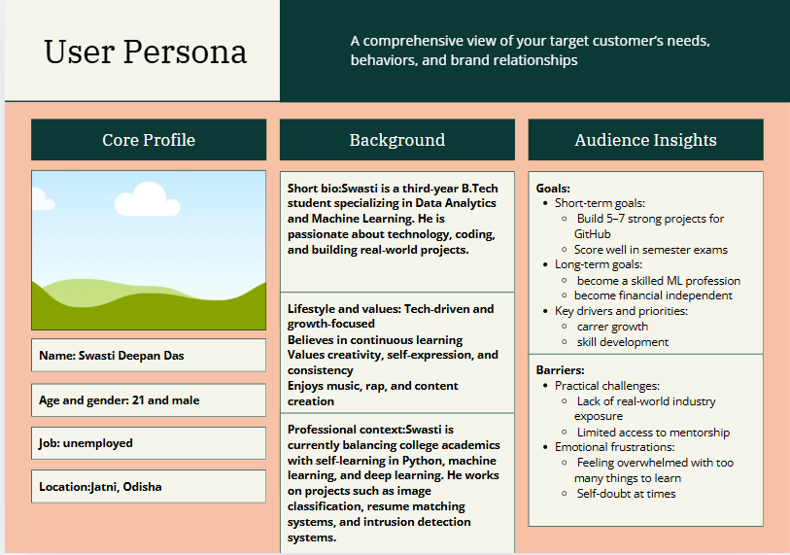

Rubrics
Concept | 10
Planning and Execution/  Practical Simulation/ Programming | 10
Result and Interpretation | 10
Record of Applied and Action Learning | 10
Viva | 10
Total | 50

Signature of the Student:
Signature of the Faculty:

ASSESSMENT
Experiment | Full Mark | Marks Obtained |  | Experiment | Full Mark | Marks Obtained
Experiment - 1 | 50 |  |  | Experiment - 12 | 50
Experiment - 2 | 50 |  |  | Experiment - 13 | 50
Experiment - 3 | 50 |  |  | Experiment - 14 | 50
Experiment - 4 | 50 |  |  | Experiment - 15 | 50
Experiment - 5 | 50 |  |  | Experiment - 16 | 50
Experiment - 6 | 50 |  |  | Experiment - 17 | 50
Experiment - 7 | 50 |  |  | Experiment - 18 | 50
Experiment - 8 | 50 |  |  | Experiment - 19 | 50
Experiment - 9 | 50 |  |  | Experiment - 20 | 50
Experiment - 10 | 50 |  |  | Average Total | 50
Experiment - 11 | 50

Date: Signature of the Faculty

LEARNING OUTCOMES:
How the Applied and Action Learning encourages Critical Thinking, Problem Solving, Idea Generation and Skill Development etc.?

How the Applied and Action Learning encourages Leadership, Team Work, Reflection and Decision-Making Capability etc.?

Date: Signature of the Students


COURSE OUTCOMES (COs) ATTAINMENT
Expected Course Outcomes (COs):
(Refer to COs Statement in the Syllabus)

Course Outcomes (COs) Attained:
How would you rate your learning of the subject based on the specified COs?

1 | 2 | 3 | 4 | 5 | 6 | 7 | 8 | 9 | 10
LOW |  |  |  |  |  |  |  |  | HIGH

Learning Gap (If any):

Books/Manual Referred:

Date: Signature of the Students

- Suggestions / Recommendations:
(by the Course Faculty)

Date: Signature of the Faculty




